

**Telematics Engineering**

Colima, Mexico. April 4th, 2017

**Subject:** Embedded Systems

**Professor:** Puente Medina José Marcos

**Practice 2**

**8 bit arithmetic calculator**

**Team 2**

**Grade:** 4th **Group:** H

**Team members**

González Medellín Javier Orlando

Íñiguez Cossío Daniel

Jáuregui Flores Luis Ángel

Rincón Martínez Demis Alberto

**Practice objective**

Design, program and apply in an embedded system an 8 bit binary calculator whit the 4 basic arithmetic operations (sum, subtraction, multiplication & division).

Apply hardware/software architecture for the practice solution.

Generate a project in programming language C for the application.

Practice using specific functions to configure digital input and output ports.

Practice arithmetic and logic operators for the transformation of digital information.

**List of tools and materials**

|  |  |
| --- | --- |
| **Quantity** | **Description** |
| 1 | Long nose pliers |
| 1 | Cutting pliers |
| 1 | Adapter: USB to RS-232 |
| 1 | SD-PIC16F8X7/18F4XXX Development board |
| 1 | 9Vdc @ 2 amps Voltage eliminator |
| 1 | Computer with software for Electronic designing and programming. |
| 1 | Protoboard |
| 29 | 330Ω @ ¼ de Watt at 5% Resistors |
| 5 | 4.7kΩ @ ¼ de Watt at 5% Resistors |
| 2 | DIP Switch 8 positions |
| 4 | Mini push button 2 pin switch |
| 13 | Diffuse led |
| 30 | Dupont 22cm cable |
| 1 | PIC 18F4620 Microcontroller |
| 1 | 16 MHz Quartz crystal oscillator |
| 2 | 100nF to 50V capacitor |

**Practice development**

The practice started discussing in the group the features that the calculator would include, asking the requirements, opining about the distribution of the components and functions (inputs, outputs, operations).

The calculator had to be applied optimizing the resources available, remembering that on the developing board some circuit pins are already connected to some components and they can’t be used in other ways.

The next part after the planning phase was the designing and testing code. From this part the work continued in teams, not the whole group. So, we designed a pseudocode which was analyzed to put the options and operations in the best order and with the less instructions possible to make an optimum use of resources.

Then, we started coding following the design made; testing it to see the errors and correcting them making any needed changes. The code was applied in functions to make it more organized and easy to read.

When the code was finished, it was loaded to the microchip and the electronic components were connected to the development board to try it on physical components. Then, the practice was finished.

**Practice Flowchart**

**Incluir diagrama de flujo!!!**

**Schematic diagram**

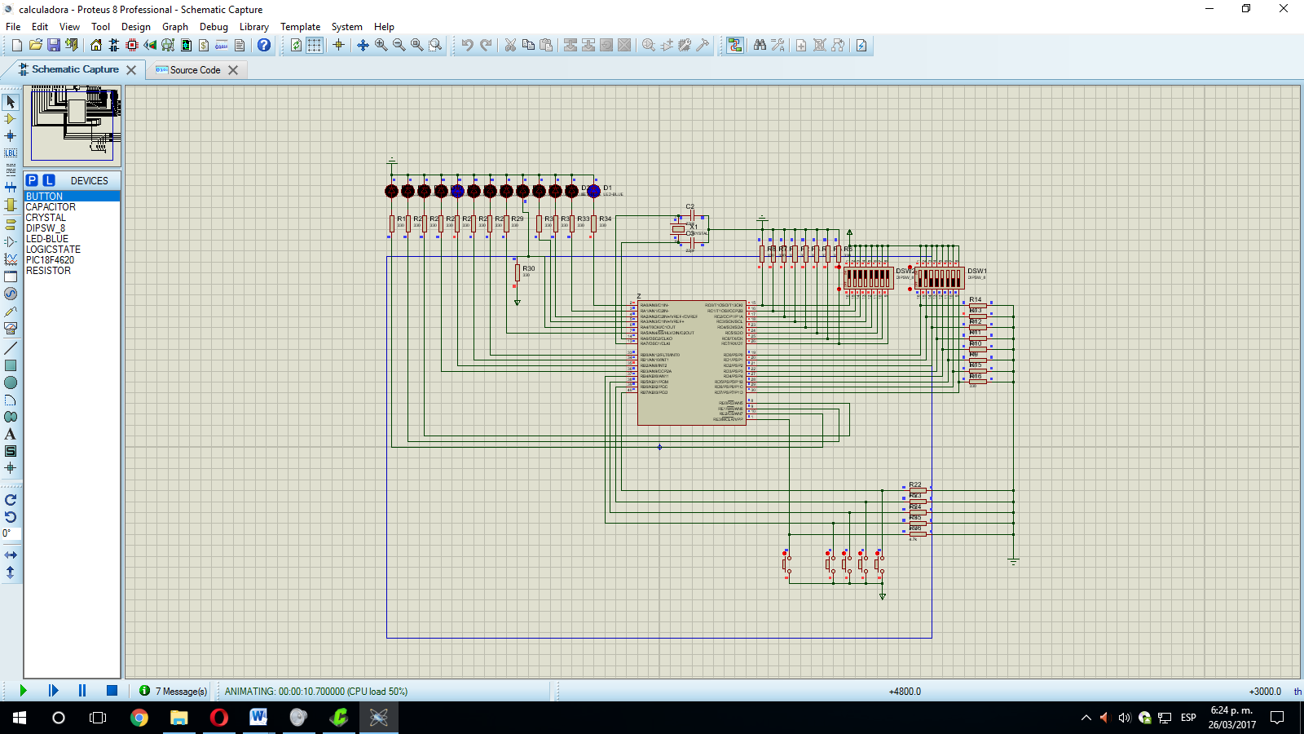

**Programs list**

Proteus 8 Professional

PIC C Compiler

Serial Bootloader AN1310 v1.05

**Observations**

**Conclusions**

**Bibliography and electronic references**

Microchip Technology Inc. (1997). *Mid-Range MCU Family. Reference Manual.*

Microchip Technology, Inc. (2008). *PIC18F2525/2620/4525/4620 Data Sheet.*